The International Dublin Gay Theatre Festival comes of age in 2021.

Over the past eighteen years, the International Dublin Gay Theatre Festival has worked to highlight LGBTQ+ stories through groundbreaking drama. Following the outbreak of COVID-19 last year, our first ever bursary scheme was launched in 2020 resulting in the publication of The Plays Inside.

Carrying on from our successes last year, we are pleased to announce an action-packed 18th Festival for 2021. This includes our online festival, in collaboration with Dublin LGBTQ+ Pride, beginning June 7th and the eleven recipients of our artists’ bursary scheme for 2021. Against the ever-present anxieties and stresses of the past year, these plays are a testament to playwrights from Ireland and across the globe triumphing over the odds to produce breathtaking works of art. In a time when we cannot be together nor express ourselves through live theatre, it is important that these voices are heard. These plays are truly inspiring works borne out of these daunting times. IDGTF’s commitment to highlighting these stories can be viewed on streaming platforms and in print over the coming weeks.

IDGTF Artistic Director, Brian Merriman, had the following to say of this year’s phenomenal effort:

2021 is the second year our stages went dark due to Covid. We have had no income and no renewal of the essential volunteer effort that has sustained us to reach our 18th year. Grant support has been lost or cuts maintained. But there is a lot of good news! Pride month in June is our time to celebrate with you what makes Dublin a unique centre for LGBTQ+ theatre worldwide.

Our small team has produced a remarkable programme to celebrate our ‘coming of age’.
2500 euros was awarded to 11 Irish and Irish-resident playwrights for new Irish LGBTQ+ plays in May.

A new book ‘IDGTF: 18 and Coming of Age the Director’s Cut’ - including 13 new plays will be published in June to celebrate our special birthday, and available on www.gaytheatre.ie or in the Dublin Pride Hub in Duke Street.

We are really delighted to bring our loyal audiences a free online virtual Festival of 13 plays from Ireland and abroad beginning from June 7th.

Thanks to our ongoing partnership with Dublin LGBTQ+ Pride, who funded the recording of new plays and who financially supported our artists, we are delighted to present this free festival of many new dramatic works. It is great to reconnect our artists with our audience online in June as we await our return to live theatre in May 2022. I salute all of the writers of the 65 new plays encouraged by our 2020 and 2021 Bursary opportunities - an unimaginable number of new Irish plays when we began in 2004. I am in admiration of the productions in our online festival who have adapted their plays to fit the digital format. We hope you enjoy being part of our 18th birthday celebrations and here’s to returning to live theatre in 2022!
The streaming of these plays will be available through Dublin Pride’s Vimeo account on both the Pride and IDGTF websites. All productions are free for viewing and uploads will start from June 7th. Tune in to catch moving stories and beautiful theatre produced against all odds.

This year was no easy feat for deciding bursary winners. We received twenty-nine wonderful plays from which the selection was made. The plays chosen are incredibly diverse and tell beautiful queer stories centring around this year’s theme. In the eighteenth year of the Festival, there was no theme more fitting than ‘Coming of Age’. All twenty-nine writers embraced this theme to explore pivotal moments in young queer lives.

We also want to acknowledge the support of the Arts Council for their support in 2021, which made it possible to run this initiative for a second year.

All of the following eleven plays can be read in this year’s book, 18 and Coming of Age: The Director’s Cut, which launches this June.

Two Gerry Sinnott Bursary LGBT Ally Bursaries
Maxine
By David O’Brien, Dublin
A play exploring loyalty, legacy and the inseparable ties of family.
Trapped and made infamous by the literary diaries of the lover she murdered, Maxine decides to carry out a plan to reclaim her girlfriend and destroy those who damaged her legacy.
A spectacular life demands a spectacular death.

Masc
By David O'Brien, Dublin
A play about male vulnerability and what happens if it's exploited by someone who has chosen hatred as their modus operandi. Thynne Davis runs a course for disenfranchised men to become 'manlier' through his acting workshop by embodying famous 'masculine' characters. However his irresponsible rhetoric radicalises those involved and has disastrous consequences.

Two Amy Dalton LGBT Ally Bursaries
Half of Nothing
By Ella Skolimowski, Dublin
Yaretsi is at that awkward age: their testicles have descended, but their periods still haven’t started. Sex ed class isn’t helping them feel any less worried. Yaretsi begins to suspect they might be a man. But that’s impossible – no one is a man, or a woman; gender is a spectrum. Anyone who claims otherwise threatens the stability of this genderless utopia. Failed by their parents, teachers and the courts, Yaretsi takes drastic action to live in the body he wants.
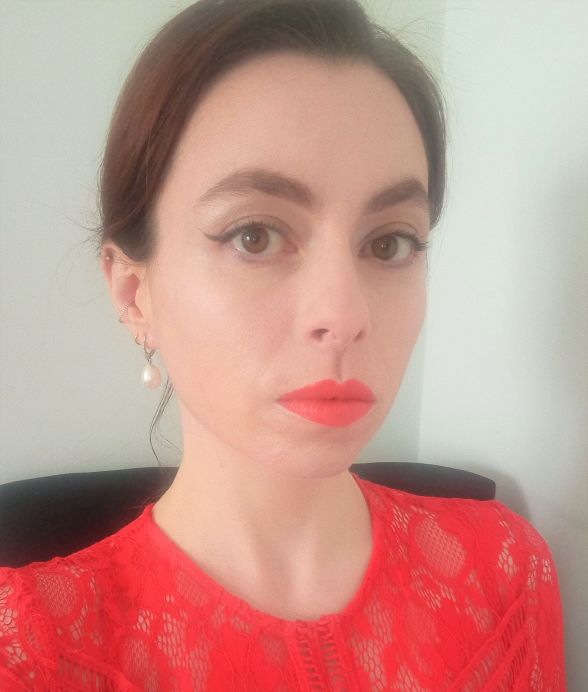

Suicide Pact
By Jason Goodwin-Tully, Limerick
Two strangers meet on a bridge one night and strike up an unlikely friendship after making a pact to kill themselves. As they share their stories, will the different paths that led them to the bridge that night and their newfound friendship be enough to save them both?
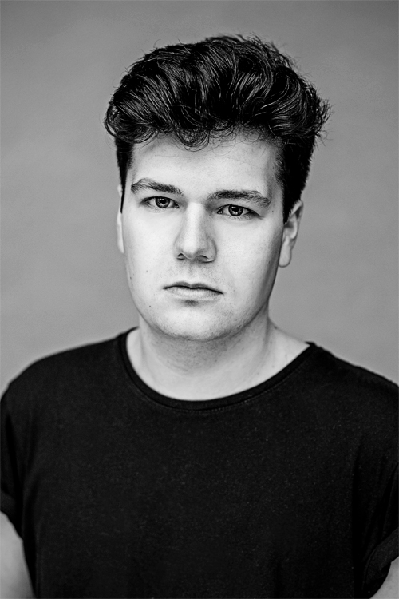

Four Dublin LGBTQ+ Pride Bursaries
The Dwyer Scandal
By Robert Downes, Dublin
A murder investigation is launched into the suspicious death of the minister for Education. Rumours are flying about the conduct of Minster Dwyer. A married man, a family man, found dead at a gay sex party with drugs in his system. What does this mean for the government, can they survive another scandal? What does it mean for the people involved? That is a matter for the courts, first we need to find out the whole story.
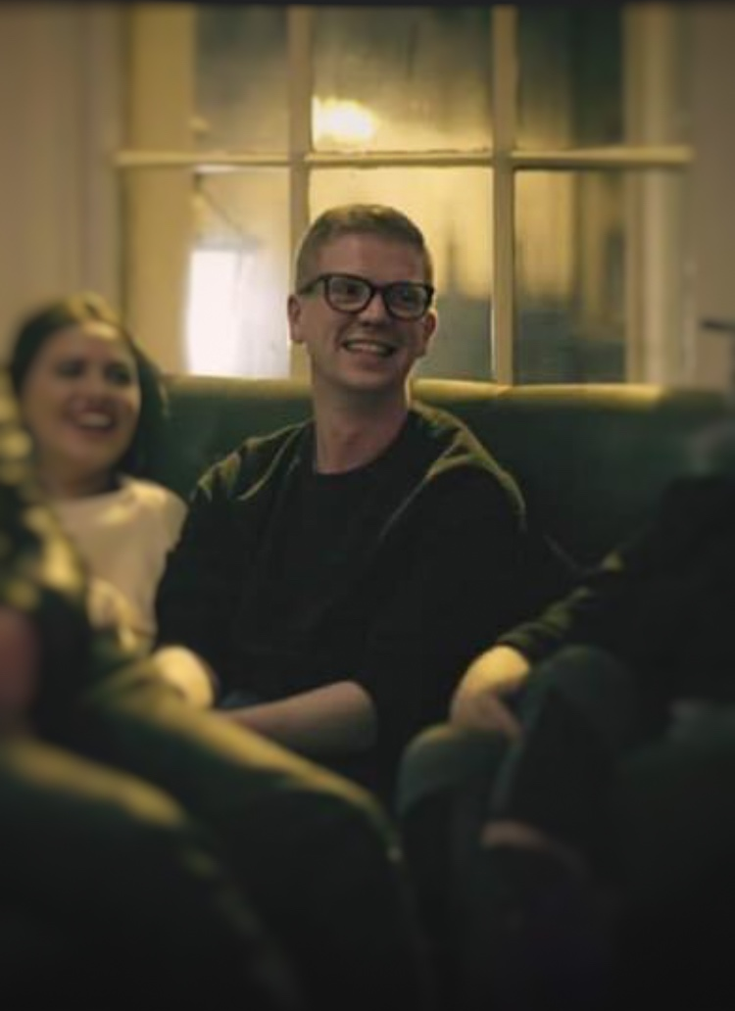

Stripes
By Marcus Bateson, Clonakilty, Co. Cork
Stripes is trying to do post-graduate life right. Unpaid Internship in a hipster magazine - check. Tiring barista job earning minimum wage - check. Paying ridiculously high rent - check. Avoiding feelings of abandonment with meaningless and regular Grindr hookups - check. Stripes is a one act play which delves unromantically into the struggles and realities of being gay and in your early twenties in Dublin - crafting tragic events with a dark humour as it explores themes of mental health, queer loneliness and grief.
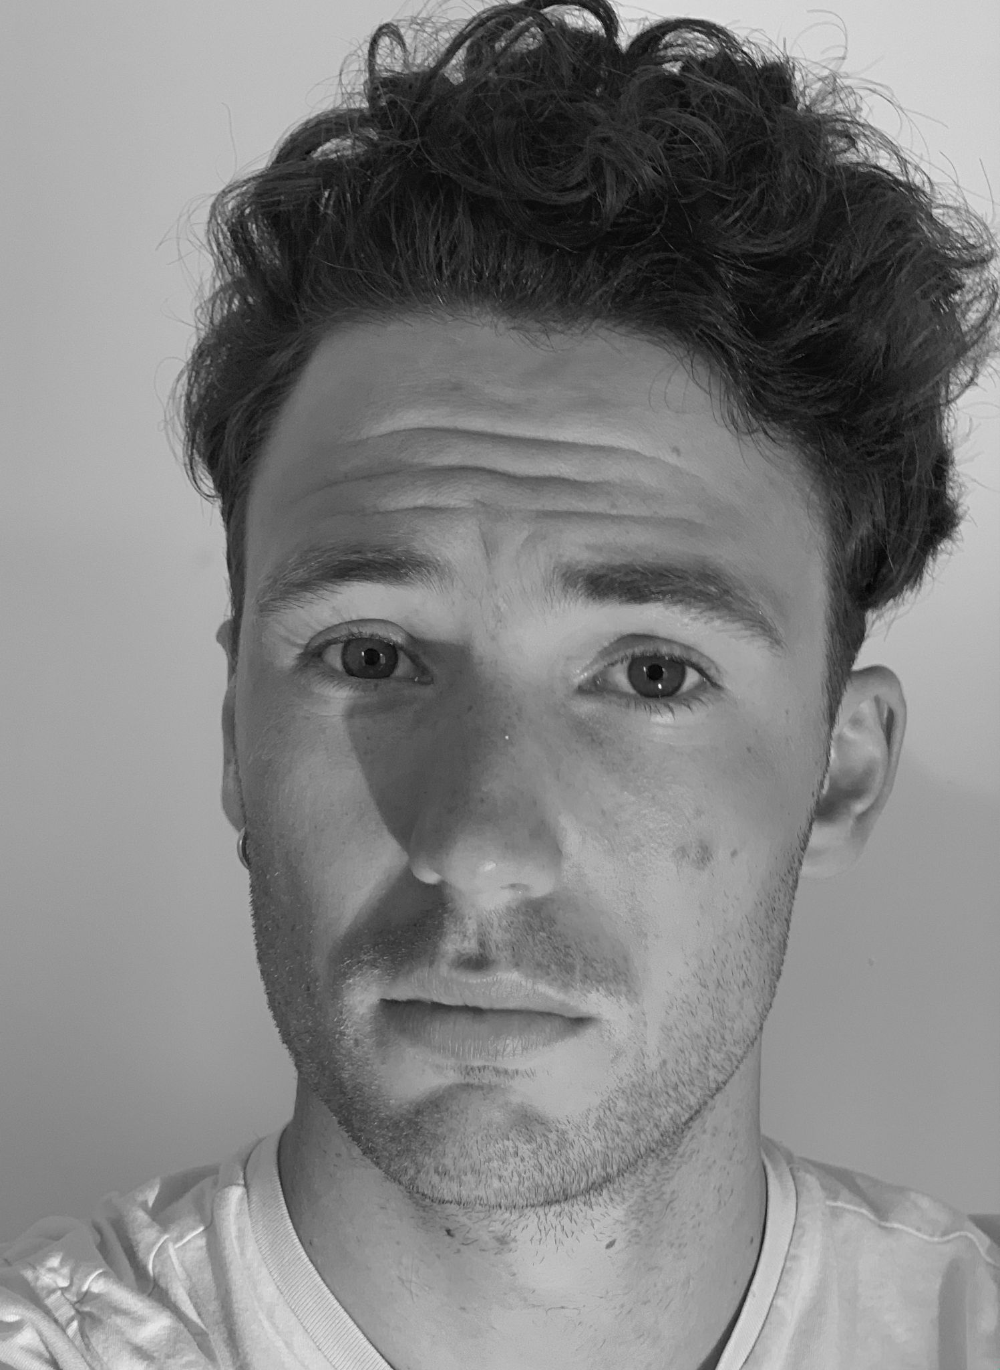

The Changing Room
By Eveanna O'Meara and Aoife O'Beirne, Dublin
It's only 11 a.m. in Marks and Spencer's changing room but a lot is already happening in those cubicles. Bra shopping isn't fun when Lorna's breasts are trying to kill her. Peggy thinks she needs parachutes not a sports bra to hold hers up because gravity isn't kind when you're 76 years of age! Charlotte has a new partner, she always thought she liked boys until she kissed a girl and liked it! Shauna needs a nursing bra, and possibly a paternity test. And Paula , the shop assistant well her mind is somewhere else, she's just turned 50 and can't stop thinking about becoming a swinger, she just needs to persuade her husband Eddie to have sex with other women! A lot of things are changing for them all, but will that change come at a cost and what if it all goes tits up!
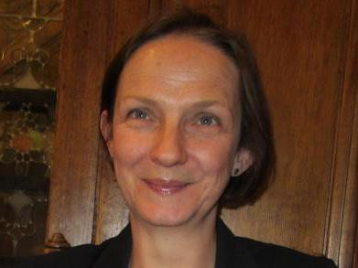

The Death of Me
By Sean Denyer, Dublin
Susanne has a great life, a job she loves, a fantastic Polish wife and a son she adores, to say nothing of a gay ex-husband and his partner with whom she has made a rainbow family to be proud of. But during make-up sex her wife, Magda, a lump in her breast is discovered, and her life may never be the same again. ‘The Death of Me’ explores one woman’s cancer journey, one which will redefine all her significant relationships, but more importantly force herself to reflect on a very difficult question. What is it I want out of life?
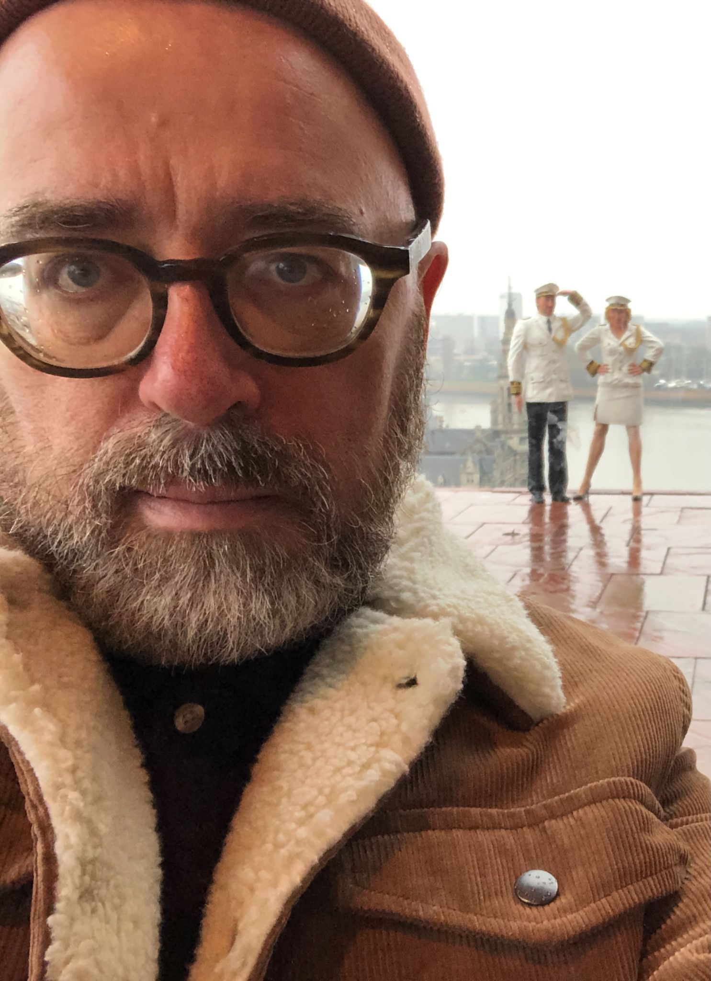

Four Terrence McNally Bursaries
The Talk
By Jonathan Hughes, Limerick
Inspired in part by my own coming out story, THE TALK is a short comedy about the conversation that takes place between father and son, after a domineering unionist father walks in on his son in bed with a man. But, you see, when Dennis Foster walks in on his son, Dennis Foster is dressed in full IRA paramilitary gear. His secret life as a republican freedom-fighter has just been outed to his staunch protestant son. During the “talk” that follows indiscretions are revealed and old secrets come to light as acceptance and forgiveness are begged for.
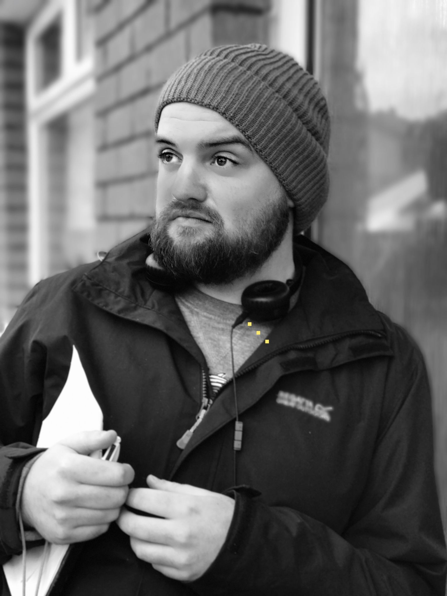

Biding My Time
By Tighearnan Noonan, Dublin
After finally finding acceptance within himself and his loved ones, a man struggles with the restrictions a new culture brings as he enters a new life with his partner.

Long Distance
By Katherine O Donnell, Cork
Long Distance is set in the mid 1980s in a Cork city domestic hallway when telephone answering machines were still a novelty. The play features a young lesbian and her older sister and how they triumph in stopping the aggressive phonecalls of a disgruntled ex-lover.
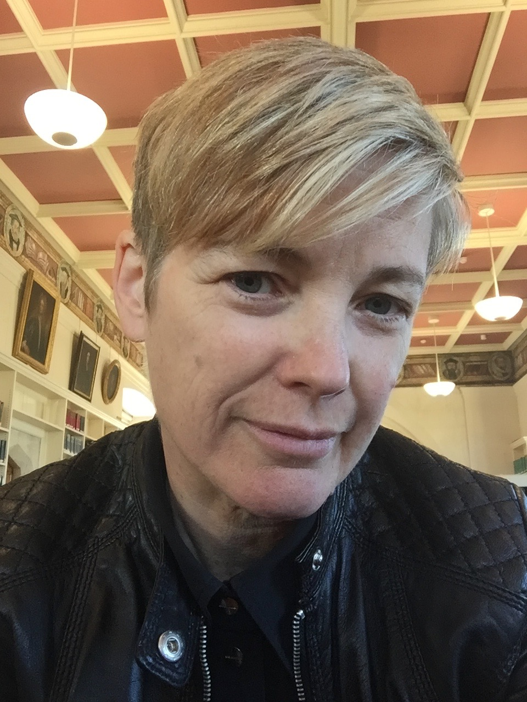

The Last Night
By ‘Benjamin Resande’, Armagh
Gerard and Anthony have bumped into each other after many many years. There is a lot of water "under the bridge". We encounter them both as Gerard makes a short trip to visit Anthony at his Turkish coastal holiday home to meet up, chat about old times, get to know each other again. It's the last night of the trip. One last night.

// Ends.

